**Good Kitty Bad Kitty**

Thank you for playing “Good Kitty Bad Kitty”! This is a straightforward Python-based game that shows you a “good kitty” or a “bad kitty” by random and is infinitely repeatable. It only requires Python to be installed on the user’s device and has no other requirements.

1. Download the file and open goodkittybadkitty.py either on IDLE or from the desktop. You should land on the main page which looks like this: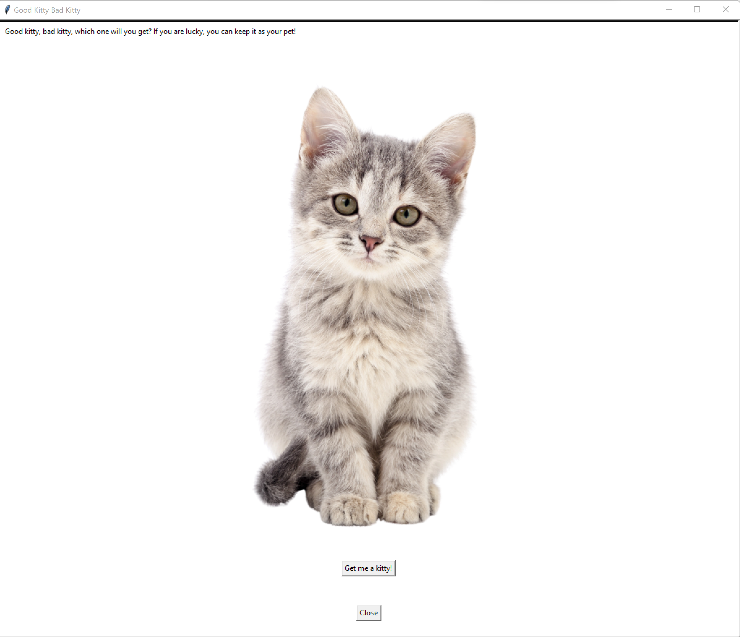
2. Click the button “Get me a kitty!” to receive the output, a pop-up window alerting the user of the result and when the user acknowledges and clicks “OK,” the user will get the picture of either a good kitty or a bad kitty. 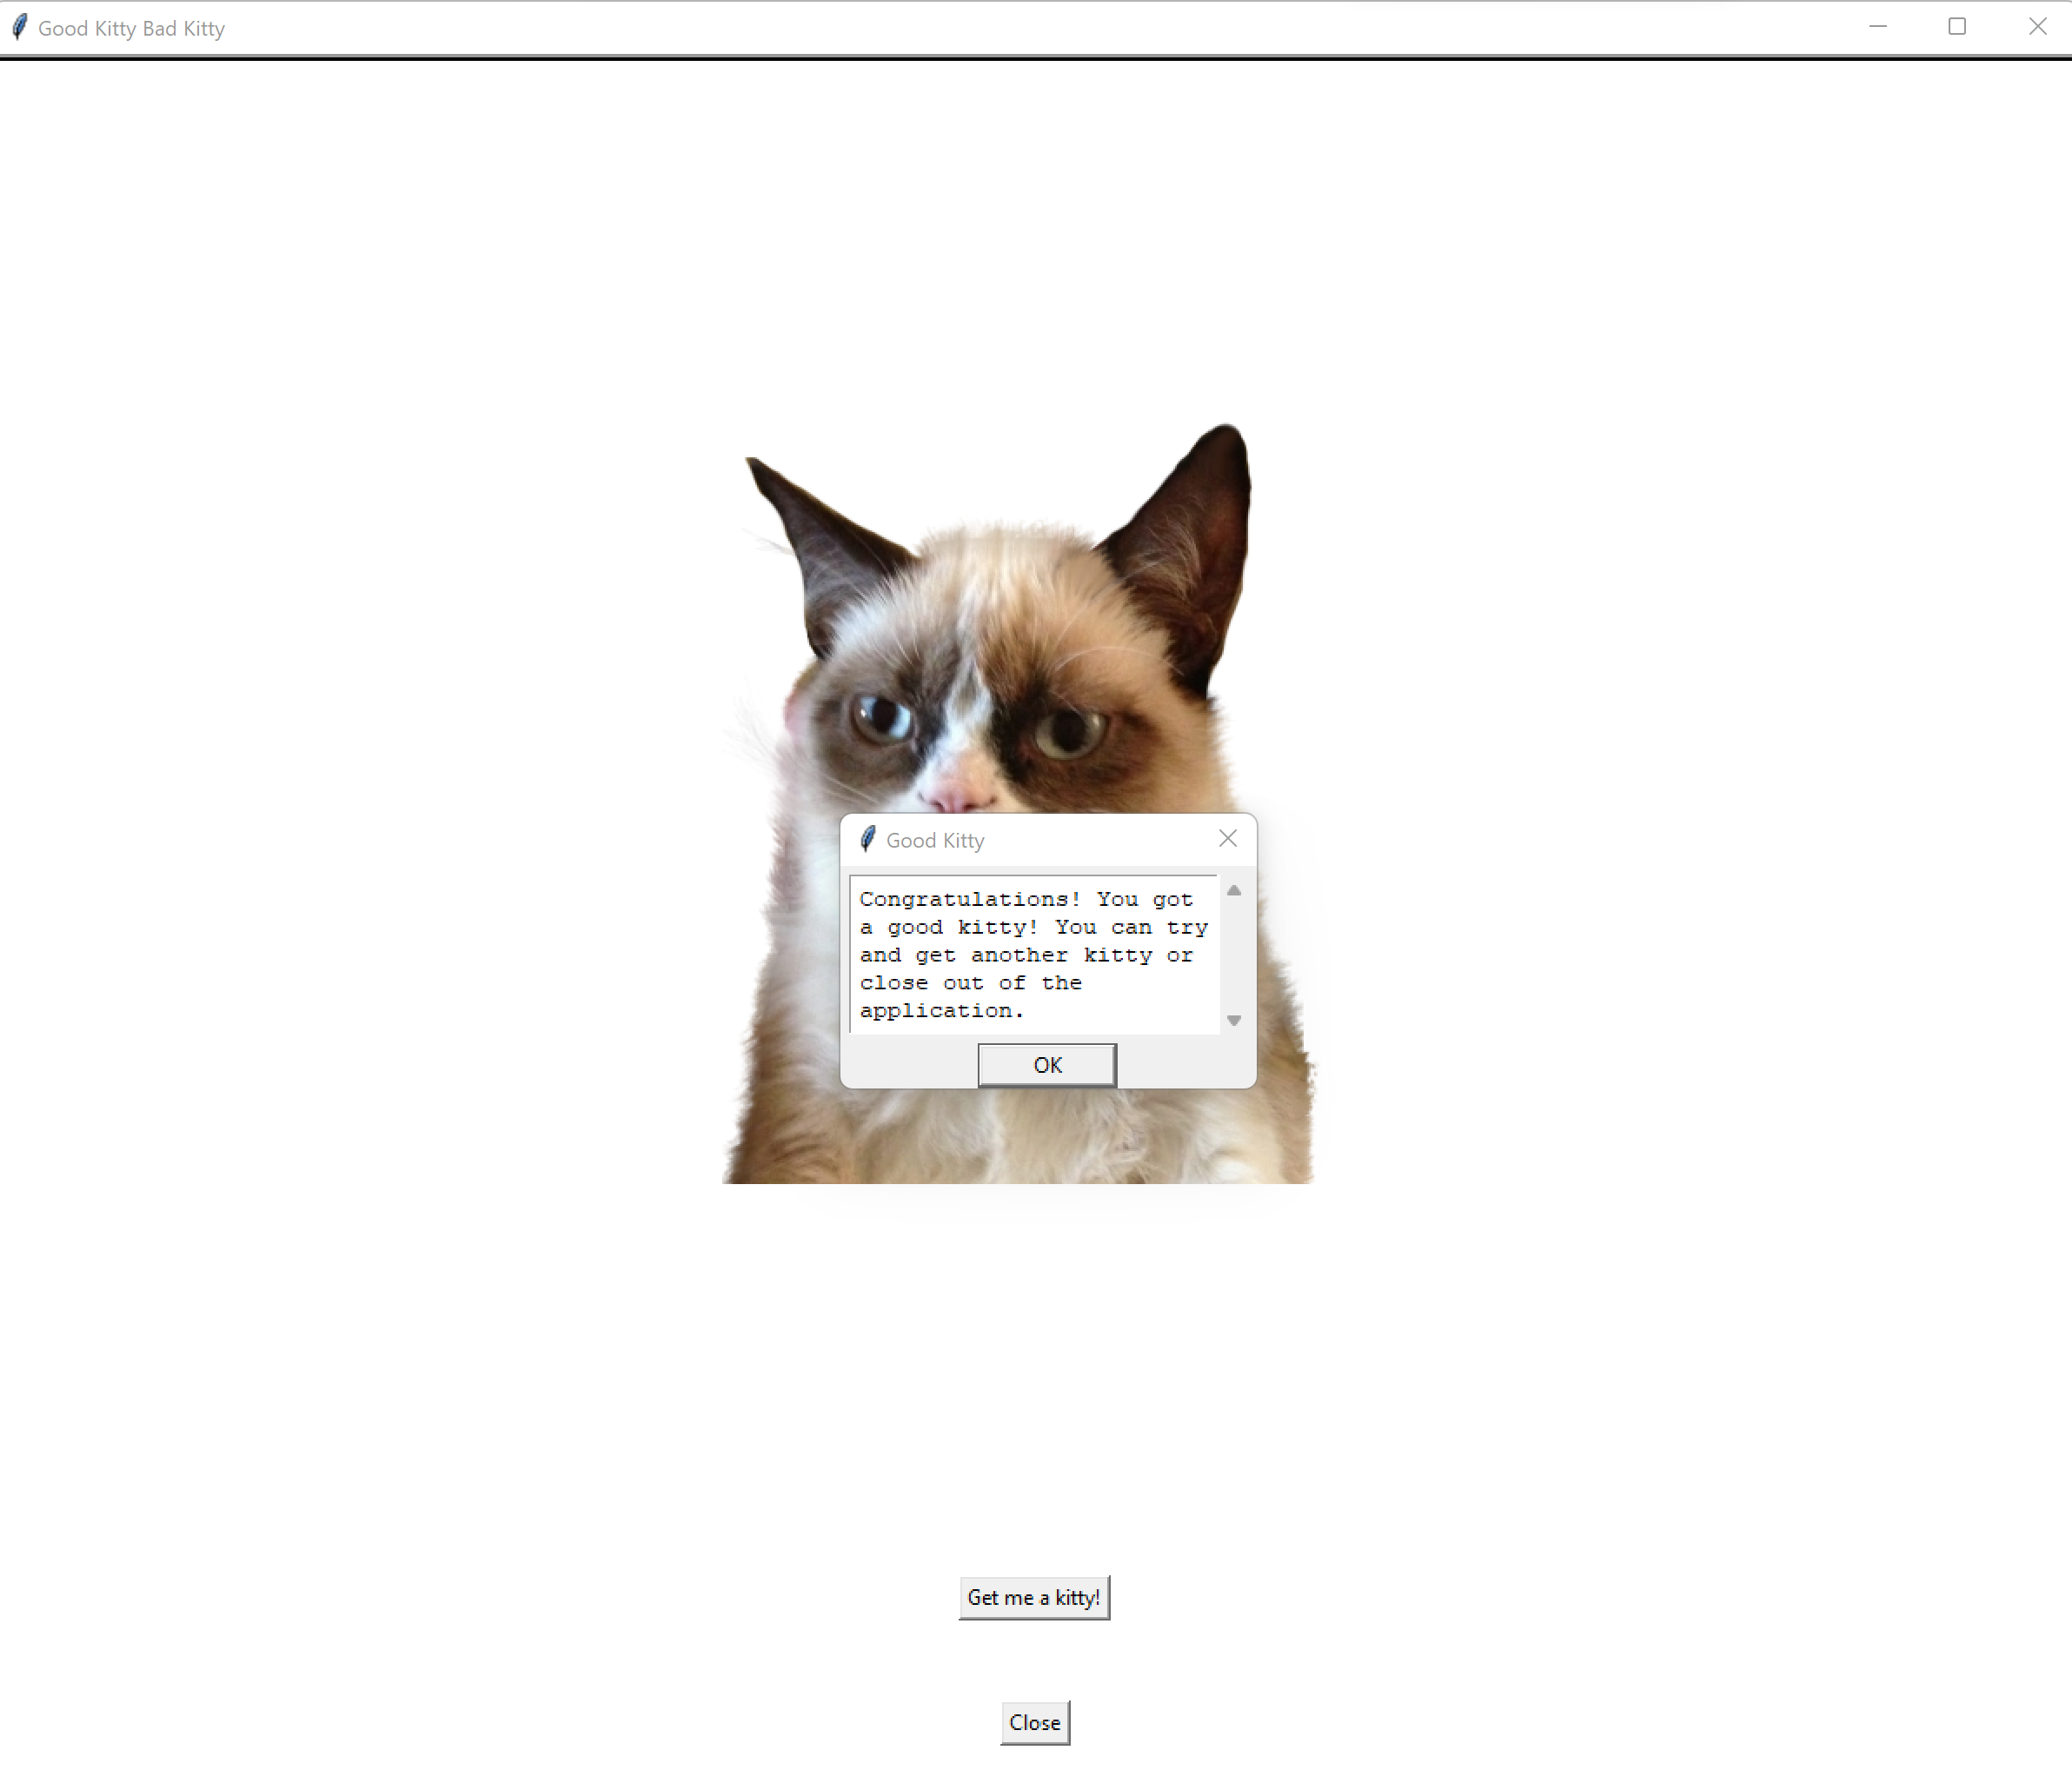
3. The user can repeat the game if they wish to or close out of the application by clicking “Close”